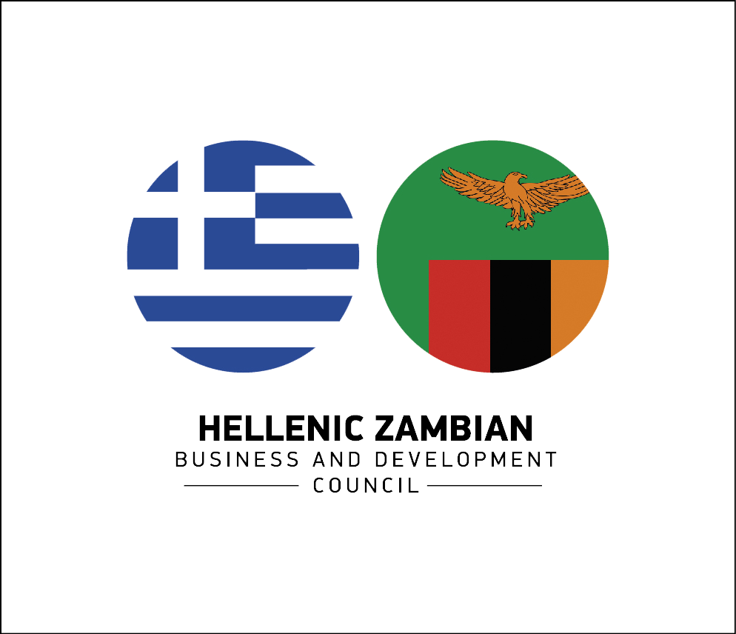

Business Mission from Greece to Zambia
October 2015

Company Profile Template

Please, complete all requested information in ENGLISH

COMPANY PROFILE |  |  |  |  |  |  |  |  |  |  |  |  |  | PARTICIPANTS
Name |  |  |  |  |  |  |  |  |  |  |  |  |  | Name
Address |  |  |  |  |  |  |  |  |  |  |  |  |  | Surname
City |  |  |  |  |  |  |  |  |  |  |  |  |  | Position
Region |  |  |  |  |  |  |  | Zip |  |  |  |  |  |  | Mob.
Tel. |  |  |  |  |  |  | Fax |  |  |  |  |  |  | E-Mail
Web: |  |  |  |  |  |  |  |  |  |  |  |  |  | Tel:
E-Mail |  |  |  |  |  |  |  |  |  |  |  |  |  | Name
 |  |  |  |  |  |  |  |  |  |  |  |  |  | Surname
Incorporation date |  |  |  |  |  |  |  |  |  |  |  |  |  | Position
Number of employees |  |  |  |  |  |  |  |  |  |  |  |  |  | Mob.
Export (% of turnover) |  |  |  |  |  |  |  |  |  |  |  |  |  | E-Mail
 |  |  |  |  |  |  |  |  |  |  |  |  |  | Tel:

B to B session
Do you want to attend B to B session?
 |  |  |  | YES NO

What is your sector of activity?
AGRO INDUSTRY - FOOD PROCESSING  AGRICULTURE  BUILDING MATERIALS  CHEMICAL  ENERGY AND ELECTRICITY  FURNITURE  ICT  INFRASTRUCTURE AND BUILDING CONSTRUCTION  MECHANIC - AUTOMOTIVE |  |  |  |  |  |  |  |  |  |  | METAL INDUSTRY  MINING  OIL & GAS  PHARMACEUTICAL  REAL ESTATE  SERVICES  TEXTILE - LEATHER  TOURISM  TRANSPORT

Please, describe the activity of your company (IN ENGLISH)

What kind of partner are you looking for?

Partnership goal:

COMMERCIAL
COMMON AGREEMENT IN PUBLIC CONTRACT AWARD
OFFER OF A LOGISTIC COOPERATION
OFFER OF COMMERCIAL INTERMEDIARY (GENERAL AGENT, FRANCHISE, DISTRIBUTOR)
OFFER OF GENERAL COMMERCIAL ASSISTANCE (PROMOTION, AFTER SALES SERVICES)
RECIPROCAL COMMERCIAL COOPERATION AGREEMENT
RECIPROCAL DISTRIBUTION AGREEMENT
REQUEST FOR A PHYSICAL LOGISTIC COOPERATION
REQUEST FOR A PRODUCER
REQUEST FOR BUYER
REQUEST FOR COMMERCIAL INTERMEDIARY (GENERAL AGENT, FRANCHISE, DISTRIBUTOR)
REQUEST FOR GENERAL COMMERCIAL ASSISTANCE (PROMOTION, AFTER SALES SERVICES)

FINANCIAL
DIRECT INVESTMENTS
OFFER FOR A GENERAL FINANCIAL COOPERATION (ACCOUNTS ADMINISTRATION, ETC)
OFFER OF EQUITY CAPITAL
OFFER TO SELL A COMPANY OR PART OF IT (INCLUDING THE SALES OF SHARES OR A BRANCH OF ACTIVITY)
PARTICIPATE FINANCIALLY IN SMEs AND RELATED COMPANIES
REQUEST FOR A GENERAL FINANCIAL COOPERATION (ACCOUNTS ADMINISTRATION, ETC)
REQUEST FOR EQUITY CAPITAL
REQUEST TO BUY A COMPANY OR PART OF IT (INCLUDING ACQUISITION OF A STRATEGIC PARTICIPATION)

GENERAL
DEVELOPMENT OF NEW PRODUCTS
IDENTIFICATION OF NEW CUSTOMERS
JOINT CREATION OF AN ENTERPRISE, CONSORTIUM OR HOLDING
MERGER, EXCHANGE OF SHARES (SWOP) OR RECIPROCAL COOPERATION
NEW PROJECTS DEVELOPMENT

TECHNICAL
SUBCONTRACTOR LOOKS FOR MAIN CONTRACTOR
MAIN CONTRACTOR LOOKS FOR SUBCONTRACTOR
OFFER OF ASSISTANCE IN R&D
OFFER OF MANUFACTURING RIGHTS: ACQUISITION, USING RIGHTS, LICENSING TRANSFER
OFFER OF TECHNOLOGICAL ASSISTANCE
OFFER OF TECHNOLOGY TRANSFER (KNOW-HOW)
RECIPROCAL/COMMON TECHNOLOGICAL COOPERATION AGREEMENT (INCLUDING AGREEMENT ON COMMON R&D)
REQUEST FOR ASSISTANCE IN R&D
REQUEST FOR TECHNOLOGICAL ASSISTANCE
REQUEST FOR TECHNOLOGY TRANSFER (KNOW-HOW)

